Recursion

& Backtracking Problems

Recursion TC & SC is almost O(n)  
computer internal memory uses stack space to store recursion call stack

Question 1 print linear number from 1 to n using recursion

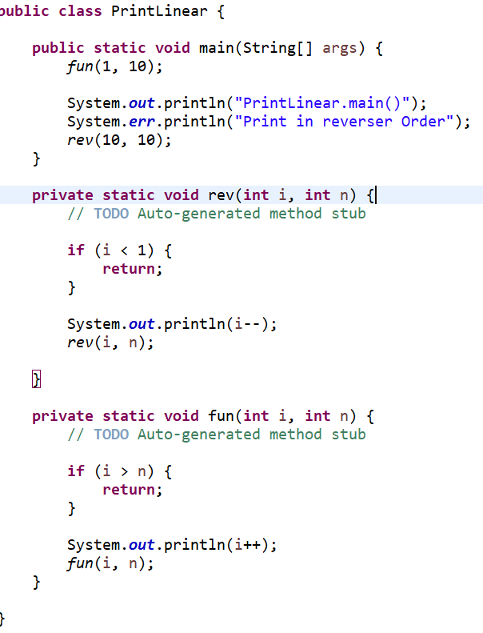

If we start from 3 then we will able to print the number in linear order as well as we can see the code below we change or swap the print & function call with each other

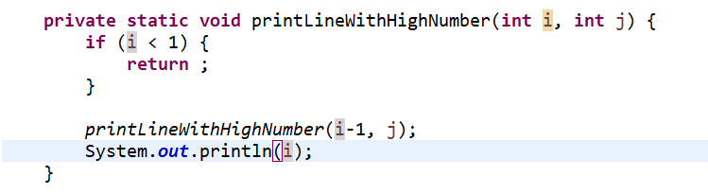

#Paramaterized And Functional Recursion

# **Combinational Sum Problem :**